Limb stretching and mobilizing exercises

Before performing any of the stretches below please read the information sheet attached.

20. Forelimb Protraction stretch
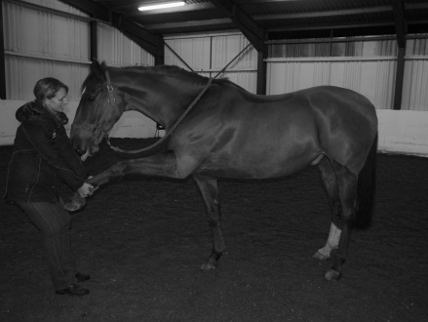
Lift forelimb at fetlock of limb you would like to stretch/mobilise and gently ease limb forwards (see picture). This mostly stretches the muscles of the shoulder and scapular regions.

21. Forelimb Retraction stretch
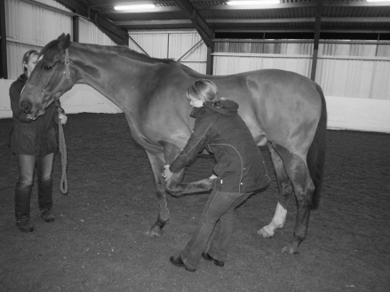
Lift forelimb at fetlock of limb you would like to stretch/mobilise and gently ease limb backwards (see picture). This mostly stretches the muscles of the shoulder, lower cervical spine and scapular regions.

22. Hindlimb Protraction stretch
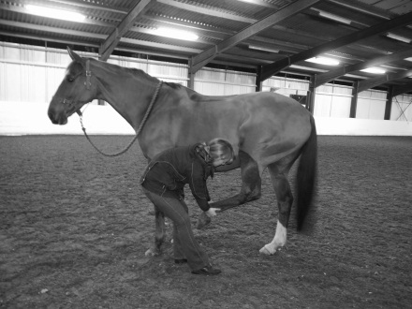
Lift hindlimb at fetlock of limb you would like to stretch/mobilise and gently ease limb forwards (see picture). This mostly stretches the Hamstring muscles of the hindlimb.

23. Hindlimb Retraction Stretch
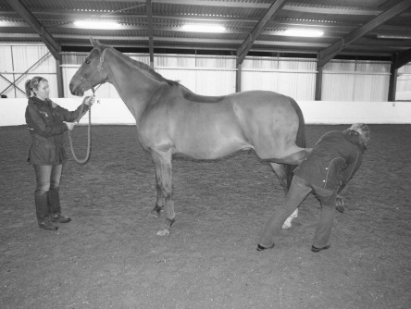
Lift hindlimb at fetlock of limb you would like to stretch/mobilise and gently ease limb backwards, ensure you remain to the side of the horse (see picture). This mostly stretches the hip flexor muscle groups of the hindlimb.

Property of Bridgefield Physiotherapy Ltd, not to be copied without permission ©

