Pelvic Stability and Balance Exercises

Before performing any of the Exercise below please read the information sheet attached.
Please take care with all Pelvic exercises and only carry out on horses you explicitly trust.

15. Low Grade Pelvic Stability 16. Low Grade Pelvic Stability
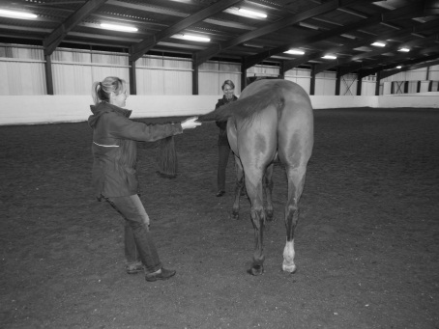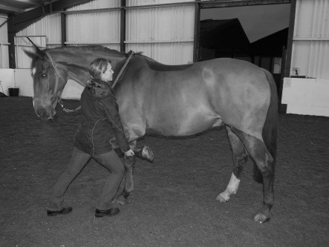
Lift a forelimb of the horse and stand to the side of their knee with it held flexed. Apply and gentle and even pressure to the horse’s shoulder in the direction of the opposite hindlimb. This aims to encourage pelvic engagement and stability of the diagonal hindlimb.
Stand on one side of the horse and pull their tail with increasing intensity whilst allowing them to pull against you. Maintain for a few seconds and repeat x5-10, daily. This mostly works the opposite hindlimb to the side you are standing.

17. Mid grade Pelvic Stability
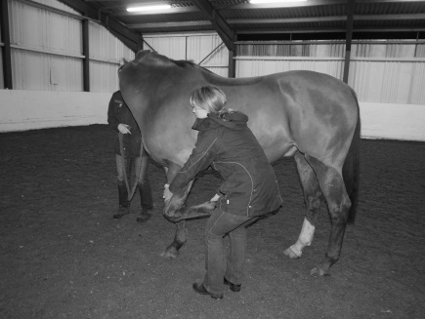
Requires two people. Lift forelimb and encourage head around away from forelimb. Try to avoid any twisting of the head. This exercise encourages increased loading to the off hind and off forelimb (see picture). Reverse forelimb raised to influence opposite limbs. Can also be used as a neck stretch exercise if the forelimb is retracted slightly .more. Repeat 5-10, daily.

18. High Grade Pelvic Stability 19. High grade Pelvic Stability
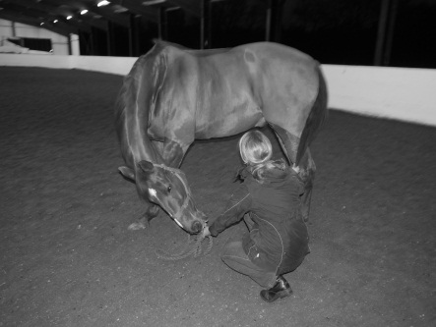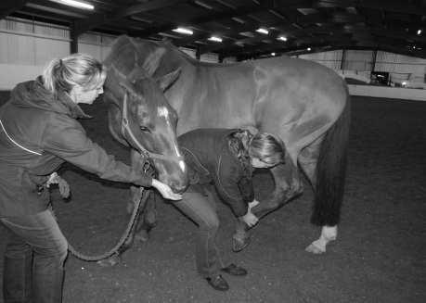
Requires two people. If aiming to enhance pelvic stability and strength of one hindlimb in particular, lift opposite hindlimb at fetlock and encourage head around towards same side. Maintain for a few seconds and then repeat x5-10 , daily.
Stand on one side of the horse. Pull the tail towards you whilst enticing their head around and down, try to avoid any head tilting. This also stretches/ mobilizes the opposite side of the back and works on pelvic stability. Repeat x5-10, daily

Property of Bridgefield Physiotherapy Ltd, not to be copied without permission ©

