Lumbosacral and Pelvic Mobilizing Exercises

Before performing any of the Exercise below please read the information sheet attached.
Please take care with all Pelvic exercises and only carry out on horses you explicitly trust.

13. Lumbosacral Rounding exercise
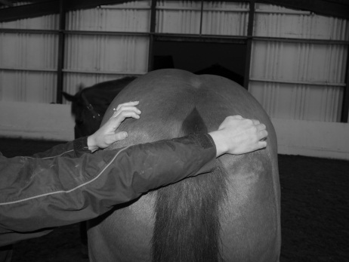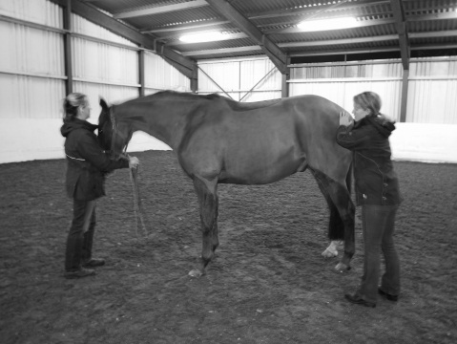
Stand to side of horse. Place your fingers either side of the tailhead (picture left) and apply even pressure stimulating a reflex lift of the lumbar and lumbosacral joints (picture right)

14. Pelvic Stretching Exercise
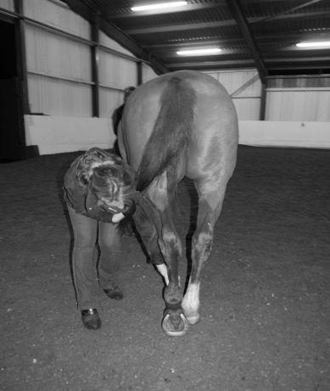
Stand on opposite side you wish to stretch/mobilize. Place nearest hindlimb fetlock in a resting position and cross behind opposite hindlimb (black arrow). Gently lean into the horse’s thigh whilst pulling the tail towards you. This will stretch the gluteal region on the opposite side (curved arrow). The greater the degree of hindlimb crossing, the greater the mobilization and stretch.

Property of Bridgefield Physiotherapy Ltd, not to be copied without permission ©

